## 



Version 23.0.0 for Salesforce Commerce Cloud - SFRA

# 

# 

# 

# Summary

This guide describes how to integrate Clearpay Payment Processor Version 23.0.0 in the SFCC reference application SFRA.

Clearpay’s Version 23.0.0 cartridge provides the following features:

* Provides the Clearpay or Clearpay payment method during checkout
* Provides the optional Clearpay or Clearpay Express Checkout feature
* Supports Clearpay’s v2.0 API
* Supports All Clearpay and Clearpay countries

# Table of Contents

Summary

Table of Contents

Component Overview

Integration Guide for New Clearpay users

[Testing](https://docs.google.com/document/d/1cH5EujjaH-PiaKSnBZqPJRn0sLyDIzXY_xWdeyFrYrw/edit#heading=h.dmdzl0ax1aag)

Features and Usage

Operations / Maintenance

User Guide

Release History

# 

# Component Overview

## Functional Overview

Clearpay provides a payment processing gateway. Clearpay’s payment gateway connects your storefront to process transactions that allow customers to make purchases.

## Use Cases

Allows checkout using the Clearpay or Clearpay payment method at the checkout screen.

## Allows checkout using the Clearpay Express Checkout feature at the cart, minicart, and product details screen.

## Limitations

The following Clearpay APIs are supported.

1. Direct Capture Payment
2. Authorize Payment
3. Create Checkout
4. Get Checkout
5. Get Configuration

The following Clearpay APIs are not supported or applicable

1. Void Authorization - Merchants will need to implement this in the event that orders can be cancelled from SFCC.
2. Capture Payment - If using our deferred payment flow the capture payment call will typically happen from an Order Management System
3. Update Shipping Courier - this will typically be implemented in the Order Management System.

The details about APIs for the different regions can be found here :

| Brand | Countries | URL |
| --- | --- | --- |
| **Clearpay** | **UK** | <https://developers.clearpay.co.uk/clearpay-online/reference> |
| **ES,IT,FR** | <https://developers.clearpay.com/v2/reference> |

## Compatibility

Available since SFCC 16.4  
Compatibility mode version this was tested against is SFRA 5.3.0

## Privacy, Payment

This integration requires access to the following customer data elements:

* Billing Address
* Shipping Address
* Order Details
* Customer Profile.

No credit card details are stored within SFCC using this integration.

# 

# 

## Express Checkout

Express Checkout is a new feature which will reduce the overall checkout steps on desktop and mobile, so that your shoppers can complete their orders quickly. It enables shoppers to checkout directly from the shopping cart or product page; and use their previously provided information to Clearpay - name, shipping address, phone number, and email, to complete their orders on your website.

After adding Clearpay’s v23.0.0 cartridge, the following will be added to your site:

* “Checkout with Clearpay” buttons on the cart page
* “Buy Now with Clearpay” button on the product detail page .  
  (Optional but Highly Recommended)

When the shopper clicks on the checkout buttons, the following will occur:

* Express Checkout begins and Clearpay’s popup form appears.
* Shoppers who have used Clearpay in the past and have enabled saved shipping and payment information will be defaulted with those options and will not have to reenter that information, but can change as desired.
* Price and shipping methods will be presented to the shopper (with integrated shipping option enabled).
* Upon clicking the confirmation button, the shopper will be redirected back to the merchant site for review or immediate order creation (BuyNow option enabled)

# 

# Integration Guide for New Clearpay users

If you are a new Clearpay user and do not have the Clearpay or Clearpay cartridge installed on your site, please follow the directions below.

## Download the v23.0.0 cartridge

The current version of the Clearpay cartridge is available directly from Clearpay.

<https://github.com/clearpayeu/clearpay-salesforce-commerce-cloud>

The version hosted on the Salesforce Commerce Cloud Partner Marketplace is an older version and should not be used.

## Build Client-Side Resources

This is required in order to build the client-side css and js files that are specific to Clearpay.

* Make sure package.json contains the correct reference to the location of the SFRA base cartridge:

| "paths": {  "base": "../storefront-reference-architecture/cartridges/app_storefront_base/" }, |
| --- |

* Run the following commands:

| $ npm install $ npm run compile:js $ npm run compile:scss |
| --- |

## Import the cartridge

Import the cartridge using UX Studio. Alternatively, can also use npm run uploadCartridge, or VSCode Prophet plugin.

## Import the site metadata

For the Clearpay integration to work, the following object structures (metadata) needs to be imported and configured in the Business manager. Follow the below steps:

1. In the cartridge bundle find metadata/clearpay-meta-import folder.
2. Find the sites folder and inside it find the RefArch folder.
3. Rename this RefArch folder to the ID of your site. If you have multiple sites to which this meta has to be imported, then copy and paste this RefArch folder to replicate for other sites. Renames those folders with ID of corresponding sites.
4. In the cartridge bundle, inside the metadata folder compress the clearpay-meta-import folder to generate the clearpay-meta-import.zip file.
5. Go to Business Manager Menu > Administration > Site Development > Site Import & Export
6. Under Import: Upload Archive : Ensure that the radio button with label Local is enabled (Else click on the radio button to enable it)
7. Click on Choose File input field, select the clearpay-meta-import.zip file from open dialog box and click on upload button
8. After finishing the upload, from the Archives list click the radio button corresponding to clearpay-meta-import.zip and click on Import button
9. Click on the OK button of the confirmation box asking “Are you sure that you want to import the selected archive?”

## Check For File Conflicts

Make sure the template, controller, and client JS and SCSS changes required for the cartridge do not interfere with changes you’ve made for your own site, or plugins that are running on your site.

The following templates are present in Clearpay's SFRA Cartridge as well as the app_storefront_base cartridge. Thus, the template in Clearpay’s cartridge will override the base template. Since Clearpay’s cartridge was built to work with the base cartridge, this should be fine. However, if you’ve made custom changes to these templates in the base cartridge, or have installed plugins which override these templates, you will need to merge the changes yourself. A 3-way visual merge tool such as Meld (<https://meldmerge.org/>) may be useful for making any necessary changes.  
  
Clearpay’s cartridge was developed using SFRA v5.3.0. In cases where templates, client JS, or CSS have been overridden, it may be useful to refer to that version to see the Clearpay-specific changes in the overridden file. In general, comments have been left in the files to make it easier to identify Clearpay-specific changes vs. base-SFRA content.

| Template File | Location & Purpose for Change |
| --- | --- |
| cart.isml | **cartridge/templates/default/cart/cart.isml**  Includes /js/clearpay.js and /css/clearpaystyle.js . Default error messaging on page will also display Clearpay-specific error messages. |
| cartTotals.isml | **cartridge/templates/default/cart/cartTotals.isml**  Display Clearpay messaging under cart totals on the cart page. |
| paymentOptionsTabs.isml | **cartridge/templates/default/checkout/billing/paymentOptions/paymentOptionsTabs.isml**  Adds a payment tab for Clearpay. |
| paymentOptionsContent.isml | **cartridge/templates/default/checkout/billing/paymentOptions/paymentOptionsContent.isml**  Include content displayed in the Clearpay payment tab. |
| paymentOptionsSummary.isml | **cartridge/templates/default/checkout/billing/paymentOptions/paymentOptionsSummary.isml**  Include content displayed in the payment summary when Clearpay is the payment method. |
| checkout.isml | **cartridge/templates/default/checkout/checkout.isml**  Make all default SFRA checkout buttons hideable with CSS. Add Clearpay checkout button. Add Clearpay Checkout Widget. Include Clearpay client-side JS and CSS. |
| addToCartButtonExtension.isml | **cartridge/templates/default/product/components/addToCartButtonExtension.isml**  Add express checkout buttons on the PDP page. |
| setItems.isml | **cartridge/templates/default/product/components/setItems.isml** |
| bundleDetails.isml | **cartridge/templates/default/product/bundleDetails.isml**  Add Clearpay messaging for bundles. Include Clearpay JS / CSS. |
| productDetails.isml | **cartridge/templates/default/product/productDetails.isml**  Include Clearpay JS / CSS. Display Clearpay messaging on product details page. |
| productTile.isml | **cartridge/templates/default/product/productTile.isml**  Display Clearpay messaging on product tile page. |
| setDetails.isml | **cartridge/templates/default/product/setDetails.isml**  Include Clearpay JS/CSS |
| catLanding.isml | **cartridge/templates/default/rendering/category/catLanding.isml**  Include Clearpay JS/CSS |
| searchResults.isml | **cartridge/templates/default/search/searchResults.isml**  Include Clearpay JS/CSS |

Similarly, if you’ve made customizations to the following JS and SCSS files, you may need to merge the Clearpay changes.

| JS File | Location & Purpose for Change |
| --- | --- |
| productTile.js | **cartridge/client/default/js/productTile.js**  Include Clearpay client-side JS |

| SCSS File | Location |
| --- | --- |
| homePage.scss | **cartridge/client/default/scss/homePage.scss**  Adds CSS for Clearpay’s checkout button. Specifically used by the minicart when opened on the store home page. |

## Upload Changes if Necessary

If you changed any files in the previous step, either in the Clearpay cartridge, or your store’s cartridge, upload those changes to the store server.

## Activate the Cartridge in Business Manager

### Set Cartridge Path

Before the Clearpay functionality can become available to SFRA, the cartridge names have to be added to the cartridge path of the Site’s settings. In order to do this, follow the below instructions:

1. Log into Business Manager
2. Navigate to Administration > Sites > Manage Sites.
3. Click on the target site name and Click on the Settings tab.
4. In the textbox Cartridges add “int_clearpay_sfra:int_clearpay_core” in front of the existing cartridge path.

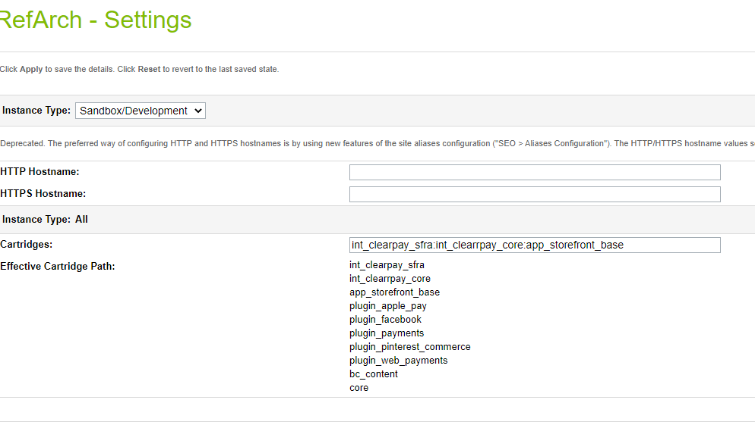

1. Click Apply.
2. To activate the cartridge for the Sandbox/Development/Production instances repeat steps 4 and 5 after selecting the appropriate instance from the Instance Type dropdown menu.
3. Repeat steps 3 to 6 for each site that is to use Clearpay.

### Set Clearpay Custom Site Preferences

In Business Manager, navigate to the SFRA Site > Site Preferences > Custom Preferences. A custom site preference group with the ID Integration_Clearpay is available. Please select it and edit the attributes according to your Clearpay account data and the data shown below.

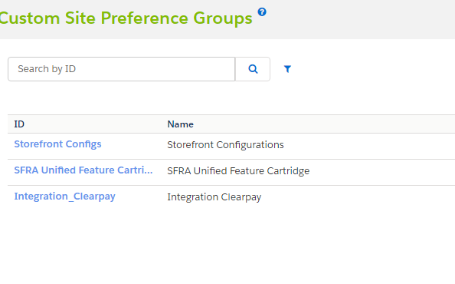

| Site Preference | Description | Default |
| --- | --- | --- |
| Enable Clearpay  (enableClearpay) | The field determines if the Clearpay is enabled / disabled in the cartridge. | False |
| Brand settings (cpBrandSettings) | Clearpay / Clearpay Brand related settings  in JSON format where   * brand – clearpay, depending on region; * service – the field is used to identify the service with Clearpay/Clearpay. * javaScriptUrl – The endpoint where the javascript library is obtained from.   Sandbox:  Clearpay (+UK) <https://portal.sandbox.afterpay.com/afterpay.js>  Clearpay <https://merchant-tools.sandbox.clearpay.com/clearpay.js>  Production:  Clearpay (+UK) <https://portal.afterpay.com/afterpay.js>  Clearpay <https://merchant-tools.clearpay.com/clearpay.js>   * learnMoreUrl – the URL that links to more information about Clearpay that users can click to view. | <default value for RefArch site. Other countries examples could be found in RefArchGlobal site meta>  {  "GB": {  "brand": "clearpay",  "service": "clearpay.service.GB.v2",  "versionApi": "2",  "javaScriptUrl": "https://portal.sandbox.clearpay.co.uk/afterpay.js",  "learnMoreUrl": "https://www.clearpay.co.uk/en-GB/terms-of-service"  }  } |
| Clearpay Display Product Details Page Information  (cpDisplayPdpInfo) | The field determines if the Clearpay messaging is displayed on the Product Details Page. | True |
| Clearpay Display Product List Page Information  (cpDisplayPlpInfo) | The field determines if the Clearpay messaging is displayed on the Product List Page. | False |
| Clearpay Payment Mode  (cpPaymentMode) | This field determines if the payment should be Authorised only or if a Direct Capture is to be used. | Merchant Specific – Select the ones to be supported. |
| CapturePaymentTimeout  (cpCaptureTimeout) | The field is used to set timeout for the Direct Timeout Capture payments. |  |
| apDelayRetry  (cpDelayRetry) | The field is required to set delay time for the unavailable service |  |
| Enable Express Checkout  (cpEnableExpressCheckout) | Enables the Express Checkout feature. | Yes |
| Enable BuyNow  (cpEnableExpressCheckoutBuyNow) | Enables the BuyNow mode. Skips review page on merchant checkout. (Note: Only used for Integrated Shipping) | Yes |
| Express Checkout Shipping Strategy  (cpExpressCheckoutShippingStrategy) | Select either Integrated Shipping (Clearpay Checkout prompts for shipping method), or deferred (merchant site handles shipping method selection) | Integrated |
| Description Express Checkout will use for In-Store Pickup  (cpStorePickupDescription) | prompt to use in Clearpay Express Checkout for in-store pickup orders | Available for next-day pickup |
| Enable Express Checkout on Product Details Page  (cpEnableExpressCheckoutPdp) | enable Express Checkout directly from the product detail page | No |
| Default Controller Cartridge Name  (cpControllerCartridgeName) | This is used for SiteGenesis only and can be ignored for SFRA. | app_storefront_controllers |
| Default Core Cartridge  (cpCoreCartridge) | This is used for SiteGenesis only and can be ignored for SFRA. | app_storefront_core |

By default, Clearpay will be disabled since the enableClearpay setting defaults to false. Change this setting to Yes to enable Clearpay. When Clearpay is turned on, by default Express Checkout will be enabled, Integrated Shipping will be enabled, and the BuyNow option will be enabled. Make sure to change these settings to the ones you wish to use on your site. When Express Checkout is disabled, the Clearpay checkout button will only appear on the checkout page.

### Set Clearpay Payment Methods

Merchant Tools > Ordering > Import & Export > Upload the “payment-methods.xml” from the metadata folder > Import the xml. Payment method with the name CLEARPAY is available that was imported.

### Set Clearpay Payment Processors

Merchant Tools > Ordering > Payment Processors > Click New Give a unique ID for the processor: “*CLEARPAY_CREDIT*” Description: **“***Pay By Installment” and click Apply*

### Set SFCC(Demandware) Service

Administration > Operations > Services > Credentials > clearpay.http.defaultcredentials > Details > Credentials tab and select required service and enter the account details.

| URL | **United Kingdom:**  Sandbox  https://api.eu-sandbox.afterpay.com/v2/  Production  https://api.eu.afterpay.com/v2/  **EU:**  Sandbox  https://api.sandbox.clearpay.com/v2/  Production  https://api.clearpay.com/v2/ |
| --- | --- |
| User | Enter the Merchant ID provided by Clearpay |
| Password | Enter the Secret Key provided by Clearpay |

### Add Clearpay Image to Payment Method

In order to display the Clearpay image on the site the image needs to be added to your site.

* Merchant Tools > Ordering > Payment Methods
* Select the payment method with ID CLEARPAY (depending on target region) and locate the image attribute and upload the image included in the cartridge (int_clearpay_sfra/cartridge/static/default/images/logo-clearpay-colour.png

### Setting up Job Schedule

This cartridge supports an Clearpay order status of PENDING by running a Job Schedule against all Clearpay Orders that are in a PENDING state. This is not required at this point as Aferpay will only respond with APPROVED or DECLINED and if the order is DECLINED the checkout cannot complete.

By default Job Step is set for SiteGenesis site. You may change this to your site.

# 

# Testing

## Checkout Flow

Once the cartridge is installed and integrated based on the instructions, please try to place an order on your sandbox to test the functionality. Even if you’ve enabled Express Checkout, place a non-Express-Checkout order by putting items in the cart and proceeding to the checkout page before placing an order using Clearpay.

* After you click on Place order then you should be redirected to the Clearpay Payment Page. If you are not registered then you will be asked to create an account

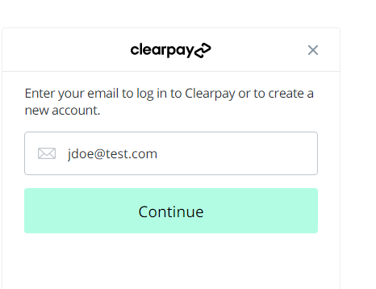

## Express Checkout Flow

If you’ve enabled Express Checkout, please try to place an order on your sandbox to test the functionality. Use the Express Checkout buttons on the cart page and verify that Clearpay’s Express Checkout popup appears and proceed through the checkout.

# 

# Features and Usage

## Clearpay Payment on Checkout

When the shopper selects the Clearpay payment method at checkout and clicks the **Place Order** button, they will be redirected to Clearpay servers to handle the payment. After the payment is complete, the shopper is redirected back to the confirmation or order review page on your store

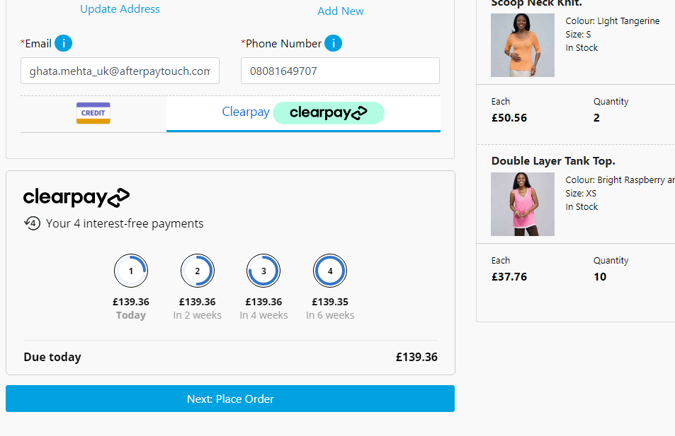

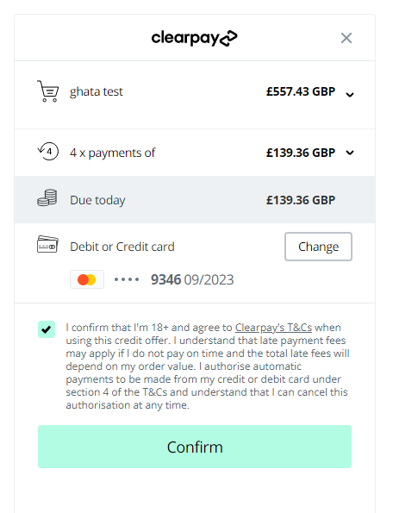

## Clearpay Product Messaging

Clearpay adds messaging on various pages in the store.

Messaging on Product Details Page:

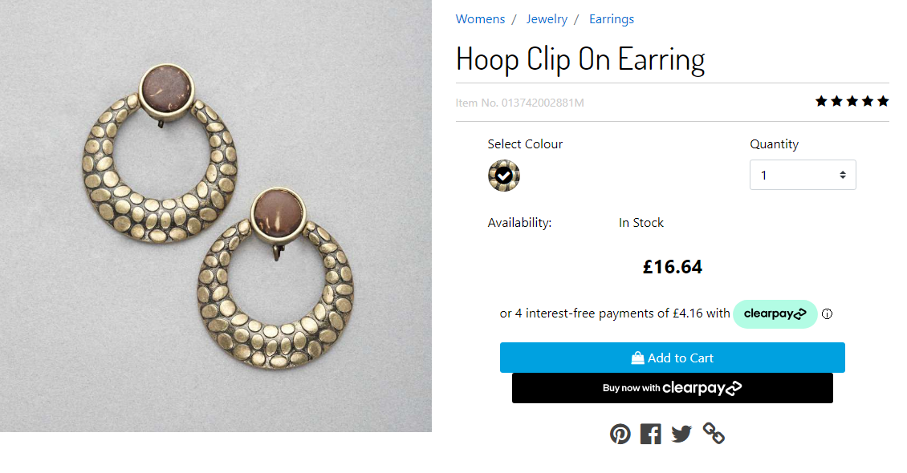

Messaging on Product List Page:

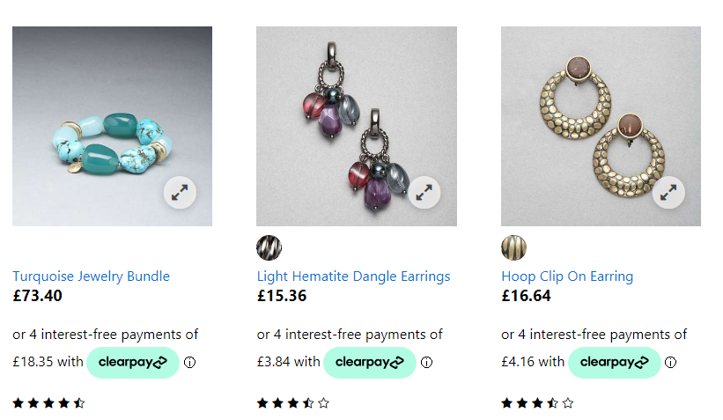

Messaging on Cart Page:

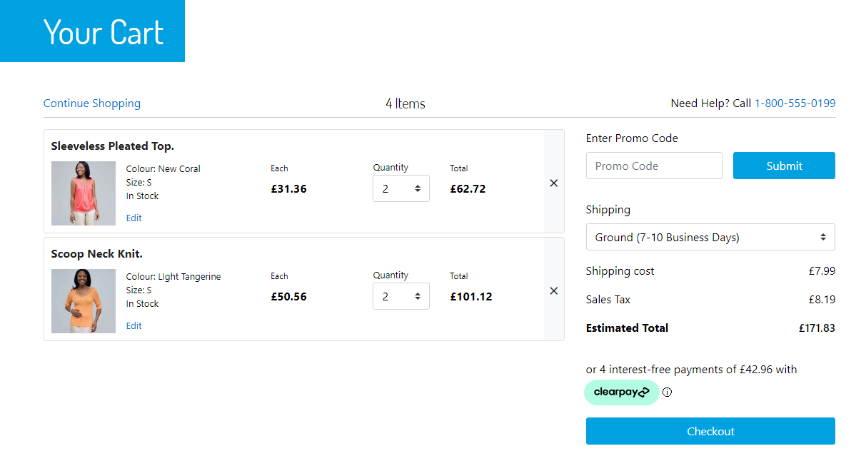

## Express Checkout

### Checkout from Cart Page

When the Express Checkout feature is enabled, new buttons will appear on the cart page and the mini cart page.

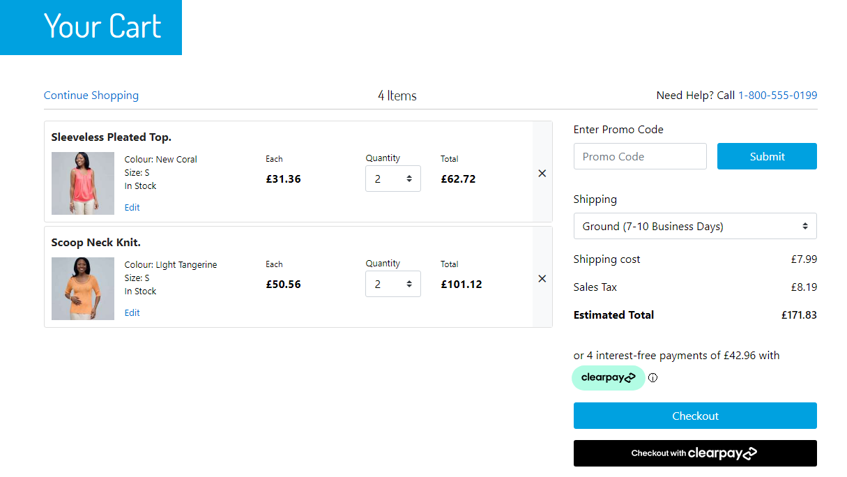

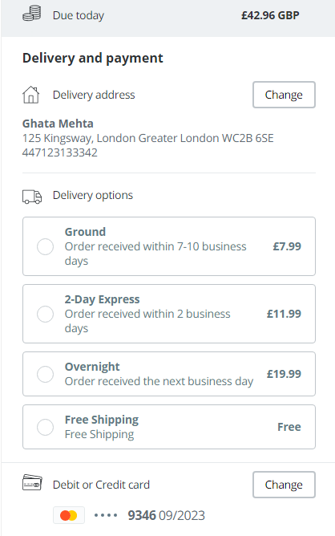

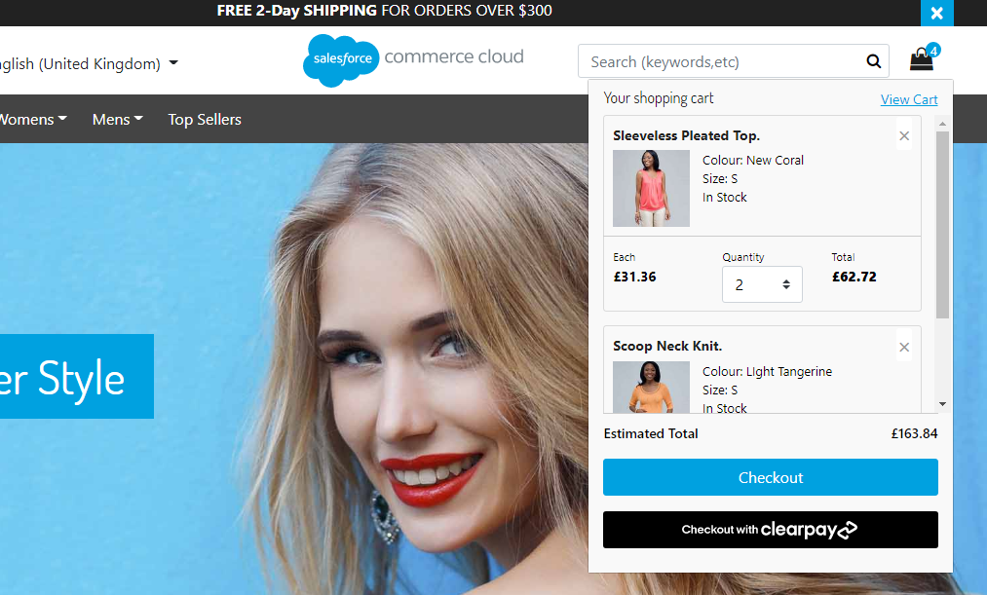

When the shopper presses either of these buttons, it will launch Clearpay Express Checkout. A popup window will appear and depending on whether the shopper has preset default checkout settings with Clearpay, they will be prompted for payment information and a shipping address. Assuming the **integrated shipping** option has been selected by the merchant, Clearpay will call a webservice, in the background, on the merchant store to get available shipping options and pricing, and display that to the shopper in the same popup window. If the BuyNow option has been selected by the merchant, the shopper can simply click “Buy Now” and will be redirected back to the merchant site, where an order will be immediately created and payment auth or capture performed

### Checkout From Product Details Page

When the apEnableExpressCheckoutPdp setting is enabled, the product details page will display a “Buy now with Clearpay” button, whenever the item is eligible to be added to the cart and when the item is below the maximum threshold amount for Clearpay (typically $2000 USD).



When this button is clicked, the current item and quantity will immediately be added to the cart, and Clearpay Express Checkout will start with all the cart contents.

### Integrated Shipping

This feature improves the user experience by integrating your shipping options directly into the Clearpay Express checkout. It streamlines the checkout process and can be combined with the BuyNow option to create a one-stop checkout.  
  
To enable Integrated Shipping, in **Business** **Manager**, make sure to set the custom preference **cpExpressCheckoutShippingStrategy** to **integrated**.

During Clearpay Express Checkout, once the shopper’s delivery address is known, and whenever the shopper changes their delivery address, the Clearpay popup will send a request to the merchant server to supply valid shipping options and costs for that address to the popup. The shopper makes the selection in the Clearpay popup, and the selected shipping option is passed back to the merchant site for order creation. This avoids the need for having the shopper make the shipping method selection on the merchant site.

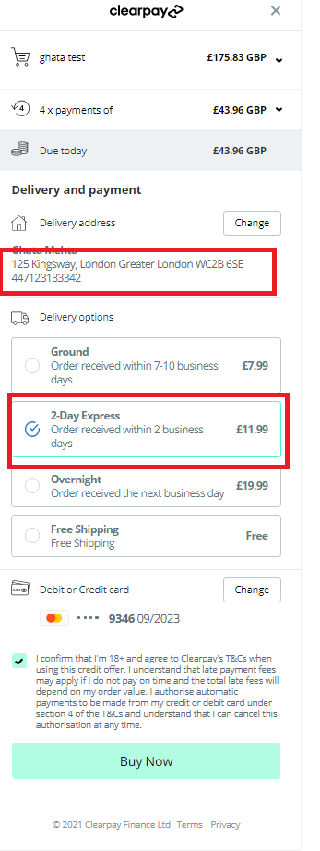

### In-Store Pickup and Integrated Shipping

In-Store pickup is supported out of the box by **Integrated Shipping**. All items in the cart must be picked up from the same store, and there can not be a mix of in-store pickup items and home delivery items in the cart. When those conditions are met, when the Clearpay checkout button is pressed (**from the cart and mini cart page only**), the store information is passed to Clearpay in the **Create** **Token** request and the shopper will be presented with an in-store pickup interface.

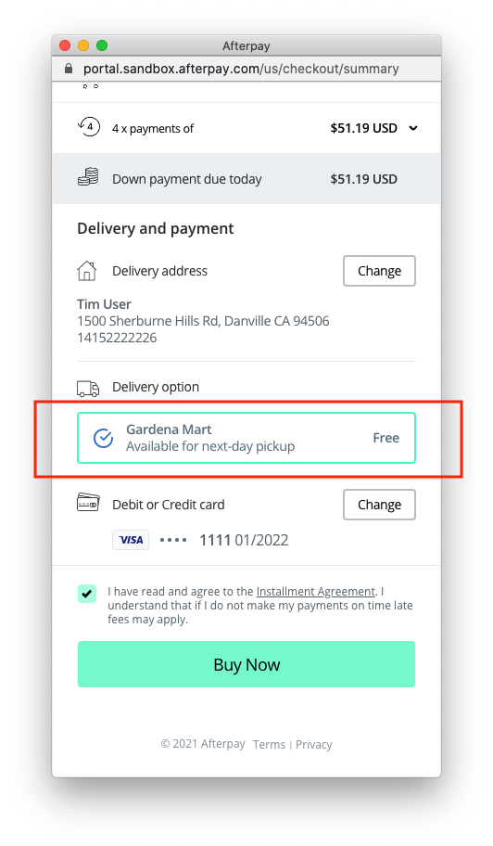

If the Clearpay checkout button is pressed from the product details page, the checkout will assume the order is for home delivery.

### Deferred Shipping

In order to handle shipping method selection on your site instead of via Clearpay’s checkout popup window, please enable the **Deferred Shipping** feature. This allows you to use the Clearpay Express Checkout to simplify the shopper’s checkout process, and quickly get the shopper’s name, email and shipping address and skip having to enter them in your checkout forms. After the shopper has gone through the Clearpay checkout process, they will be redirected back to the Shipping/Order Review page on your site to proceed with checkout.

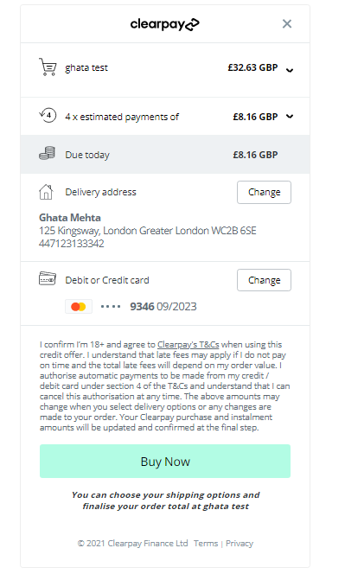

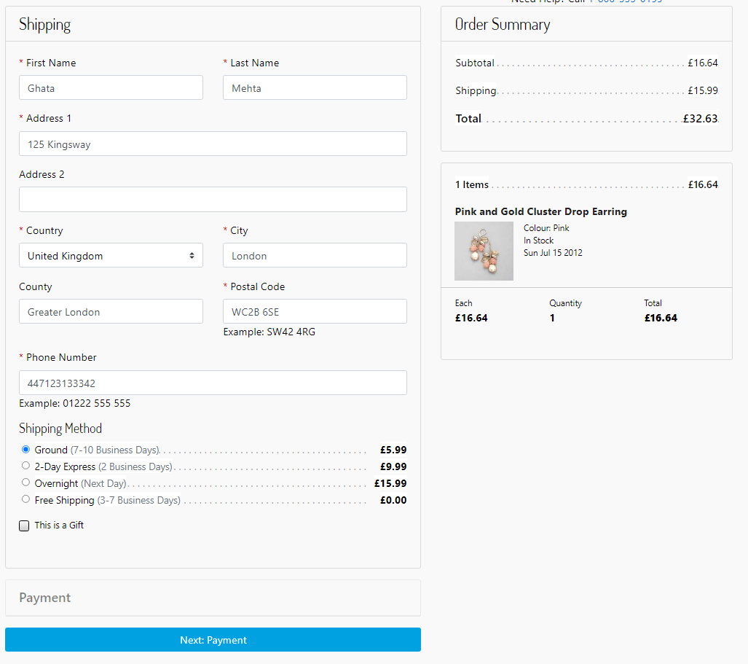

To enable Integrated Shipping, in Business Manager, make sure to set the custom preference **cpExpressCheckoutShippingStrategy** to **integrated**.

### BuyNow (Immediate capture) Feature

When the Express Checkout is complete, you may either capture payment immediately or continue the checkout on your site. If you are capturing immediately, set the **cpEnableExpressCheckoutBuyNow** custom preference setting to **Yes** - this shows the user a “Buy Now” button at the end of their Clearpay checkout. Upon clicking, control is returned to your site for payment capture, and an order summary will be displayed.



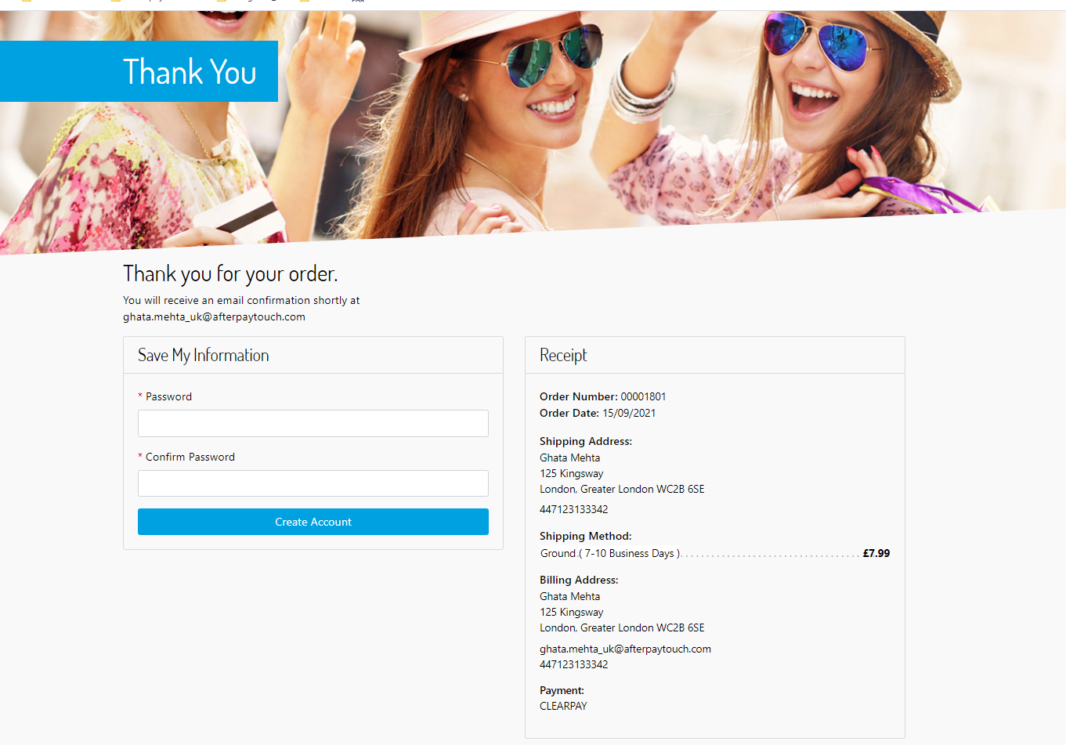

**Note**: The BuyNow feature only applies to the Integrated Shipping option. For Deferred Shipping control needs to return to your site for shipping method selection, so a BuyNow feature would not make sense.

### Clearpay Widget

The Clearpay Widget is not a new feature in and of itself, but is an essential component that needs to be placed on your site if the order value is going to change after the Clearpay Express checkout has finished. This will be the case unless the **Integrated** **Shipping** and **BuyNow** features are enabled.  
  
It serves several purposes:

1. To ensure the user has seen and agreed to an accurate payment schedule.
2. To verify that the final amount captured matches what the user has seen.
3. To provide information to the merchant such as the first payment amount for display purposes.
4. To inform the merchant of any barriers to purchase, for instance the user having gone over their payment limit with Clearpay.

The Clearpay Widget will be displayed on the final checkout summary screen (for deferred shipping):

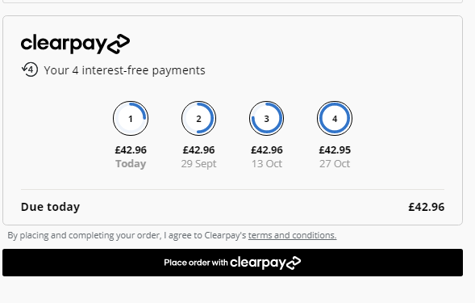

It will also be displayed on the billing screen if the shopper has already been through the Clearpay checkout process and are now back on your site to complete the checkout (see Express Checkout Finalization Flow below). It is only displayed when Clearpay is the active payment instrument for the cart.

The **Place order with Clearpay** button will always be placed below the Clearpay Widget to ensure that the shopper has seen the widget before placing the order.

### Express Checkout Finalization Flow (ECFF)

Unless you are using the **Integrated** **Shipping** feature with the **BuyNow** option, the shopper will be redirected back to your site after the Clearpay checkout. During this phase, in SFRA, the shopper can still make arbitrary changes to their cart (e.g. add/remove items, apply coupons and gift certificates, change shipping address and methods, etc) . However, Clearpay’s link cartridge will remember (using session state) that the user is currently in the Express Checkout Finalization Flow. This will affect the behavior of the Clearpay checkout buttons:

* When the “Checkout with Clearpay” button is clicked, instead of redirecting to Clearpay to checkout again and generate a new token, the button will take the shopper to the cart summary page, where the Clearpay Widget will be displayed, along with the “Place Order with Clearpay” button.

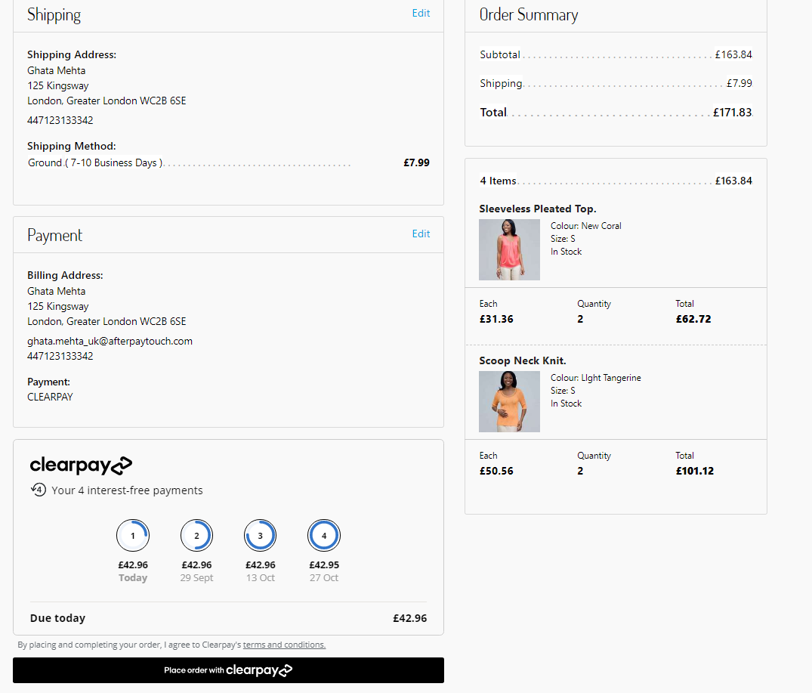

* When the “Buy now with Clearpay” button is clicked on the product detail page, the product will be added to the cart and the shopper will be directed to the summary page as well. The default shipping method used in the rest of the order will be used for the newly added product as well. The Clearpay Widget will display the total order amount, and upon clicking the “Place Order with Clearpay” button, the order will be created and payment will be captured.

### Exiting from Express Checkout Finalization Flow:

There are several conditions which will cause the shopper to exit from ECFF:

* If the user explicitly chooses another payment method on the billing page, and clicks submit, Clearpay will be removed as a payment method.
* If the user navigates to any page which normally contains an Clearpay Widget (the billing page and summary page), but does not have Clearpay set as a payment instrument for the cart, they will no longer be in ECFF.
* After the shopper clicks **Place Order with Clearpay**, regardless of whether the transaction was successful or not, they will no longer be in ECFF. The **Place Order with Clearpay** button will also fail if the user is not in “Express Checkout Finalization Flow”, but this should not happen unless the shopper opens multiple browser windows and clicks on the button in an old window when the session state has already changed.
* The user’s browser session expired

After exiting from the Express Checkout FInalization Flow, clicking on “Checkout with Clearpay”, or “Buy Now with Clearpay” buttons will start the Clearpay checkout process again.

### Express Checkout Behavior

### Order Fields

Orders created via Clearpay Express Checkout will look the same as non-Express Checkout orders, with the following exceptions:

* The Billing Address field will display the shipping address. Since Clearpay is handling the checkout, after the express checkout popup closes, the shipping address is returned from Clearpay and used to populate both the shipping address and billing address in the cart. Thus, when the order is created, it will be the shipping address unless the shopper has specifically modified the billing address before finalizing the transaction.
* **Clearpay Express Checkout** - will be true for express checkout orders
* **Clearpay Express Checkout Capture Checksum** - this is a checksum generated by the Clearpay Widget, and indicates the total amount and payment schedule the shopper was shown before placing the order

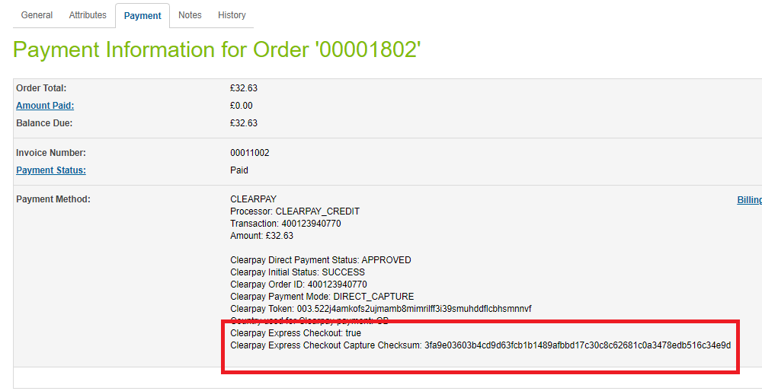

### Billing Page Address Changes During ECFF

On the Billing Page, if the billing address is changed right before the shopper clicks “Place order with Clearpay” (during ECFF), the changed data will be ignored since the form is not actually submitted to the server. This should be unimportant since Clearpay is handling the payment process and the billing address fields would typically be prepopulated with the shipping address.

### Error Behavior

When there are payment-related errors, the shopper will be redirected back to the billing page and an error message will be displayed.

Note that if the shopper was in Express Checkout Finalization Flow, they will no longer be after a payment-related error.

When there is a payment-related error, an order will generally already have been created by SFCC. This can occur in the following scenarios:

* Capture was declined
* Shopper modified the cart in the short period between when SFCC created the order, and before the payment capture via Clearpay.
* The merchant site was unable to communicate with Clearpay’s payment servers

The order will have a “Failed” status in these cases, and the payment status will be “Not Paid”.

### ECFF Behavior

Because the shopper can make arbitrary changes to their billing address and shipping address during ECFF, occasionally the shipping and billing address on-file at Clearpay may not match the information created in the order. However, this should not matter since you (the merchant), will always have the correct shipping address, and Clearpay will always have the correct billing address.

### Express Checkout Limitations

### No Multiple Shipping Destinations Prior to Clearpay Express Checkout

Express Checkout will only work when all items in the cart are set for **Home Delivery** OR all items in the cart are set for **In-Store** **Pickup** from the same store. If neither of these are true, and the shopper clicks the “Checkout with Clearpay” button, an error message will appear indicating that Clearpay is unavailable for the current cart.

The shopper can still pay with Clearpay using the standard checkout process (selecting Clearpay on the billing page), but will not be able to use express checkout features.

Even though the shopper will not be able to use Express Checkout in these instances, the exception is if they’ve already gone through the Clearpay Express Checkout, and are now in the ECFF on your site. They will be able to add items to cart, ship to multiple locations, and/or pick up from multiple stores. The order can still be created and payment captured once they click on the “Pay now with Clearpay” button. At this point, since Clearpay is only capturing payment, the shipping limitations no longer matter.

### Billing Address is not Passed to Merchant

If a shopper uses Clearpay Express Checkout, the billing address is typically not passed back to your site from Clearpay. In non-BuyNow checkout flows, the billing address will instead be populated with the shipping address.

### Other Limitations

* Currently, there is no support for a “Buy Now with Clearpay” from a wishlist page.
* Currently, there is no support for a “Buy Now with Clearpay” button on a product bundle page.
* For in-store pickup orders, Clearpay Express checkout does not support adding a message to the store. If finalization happens at the merchant site, the shopper could go back to the shipping screen and add the message.

### Express Checkout Implementation Details

### Overview

Particularly for sites that have made substantive changes to the base SFRA store, we’ve provided some details on how certain features were implemented. This would make it easier to understand how your site’s customizations may potentially require some modifications to Clearpay’s cartridge to work properly.

### Checkout Button Behavior during ECFF

In the isml templates, buttons which behave differently during ECFF will have an <isif condition=”${isExpressCheckoutFinalize}”> to control the button behavior. In **int_clearpay_sfra/cartridge/templates/default/cart/checkoutButtons.isml**, during ECFF, a button will be displayed that upon clicking, will run the “ClearpayExpress-ContinueFinalize'' endpoint. This is an endpoint that will navigate to the cart summary page. When not in ECFF, the button has the (id=”clearpay-express-button”), which has been set as the target for launching the Clearpay Express Checkout popup.

If your site is designed in such a way that ECFF wouldn’t make sense and you’d prefer the user go through Express Checkout again whenever they click the “Checkout with Clearpay” or “Buy now with Clearpay” buttons, this is behavior that’s easily changeable in the template.

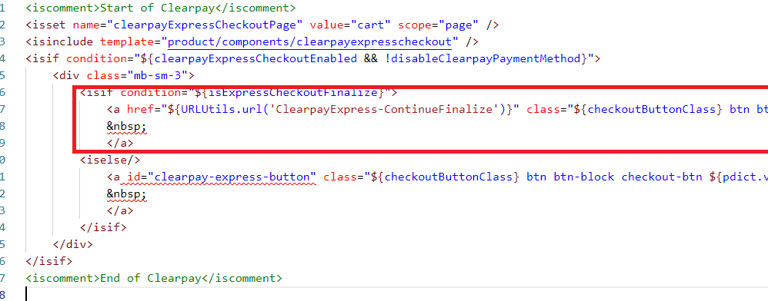

### Client-Side Javascript for Express Checkout

In order to support Express Checkout in the SFRA checkout flow, we run client-side JavaScript to determine when to hide/show the Express Checkout Widget and the Place Order with Clearpay buttons. Most of this logic is located in:

customCheckout.js

| // Call handleStage when page is loaded/reloaded  handleStateChange();   let cmElem = document.querySelector('#checkout-main');   // Call handleStage with new stage whenever we detect the stage change  // SFRA base changes attributes on #checkout-main to indicate stage of checkout flow changes  if (window.MutationObserver) {  var observer = new MutationObserver(function (mutations) {  for (let mutation of mutations) {  if (mutation.type === 'attributes') {  handleStateChange();  }  }  });  observer.observe(cmElem, { attributes: true });  } else {  // If no MutationObserver support, just use interval to poll state  var checkState = setInterval(function () {  handleStateChange();  }, 500);  }   // Call handleStage with new stage whenever clearpay payment tab is pressed  let tabelem = document.querySelector('.afterpay-tab') ? document.querySelector('.afterpay-tab') : document.querySelector('.clearpay-tab');  if (window.MutationObserver) {  var observer = new MutationObserver(function (mutations) {  handleStateChange();  });  observer.observe(tabelem, { attributes: true });  } |
| --- |
|  |

We use 2 MutationObservers that look for attribute changes on the ‘#checkout-main’ - the attributes on this element change as the checkout progresses through the stages of shipping / payment / placeOrder / submitted, so we use that as well to determine if the stage changed. The other MutationObserver checks if the Clearpay payments tab has been clicked.

Individual elements then use the following css classes to indicate whether the element should be shown in a certain state.

| **.cp-checkout-ship** - only shown during shipping stage  **.cp-checkout-pay-tab-ecf** - only shown during payment stage **if** Clearpay tab is active and shopper is **in** Express Checkout Finalization Flow  **.cp-checkout-pay-tab-noecf** - only shown during payment stage **if** Clearpay tab is active and shopper is NOT **in** Express Checkout Finalization Flow  **.cp-checkout-pay-notab-ecf** - only shown during payment stage **if** Clearpay tab is NOT active and shopper is **in** Express Checkout Finalization Flow  **.cp-checkout-pay-notab-noecf** - only shown during payment stage **if** Clearpay tab is NOT active and shopper is NOT **in** Express Checkout Finalization Flow  **.cp-checkout-po-ecf** - only shown during checkout stage during Express Checkout Finalization Flow  **.cp-checkout-po-noecf** - only shown during checkout stage **if** shopper is NOT **in** Express Checkout Finalization Flow |
| --- |

If you’ve customized the checkout UI for your site, please make sure there are no conflicts between this and your customizations.

### Add To Cart from PDP Page

When the shopper clicks the Buy now with Clearpay button on a PDP page, the item is added to the cart and the Express Checkout widget is displayed. In order to make this feature as flexible and easy to integrate as possible, the button acts as a normal Add to Cart button of the store, but has an additional onclick handler which starts the Express Checkout widget and waits 200ms before running the CreateToken controller endpoint on the server. The 200ms delay ensures that the item has been added to the basket.

In order to achieve this, we call initClearpay and specify a commenceDelay value of 200.

In clearpay.js:

| **if** ($('#clearpay-express-pdp-button').length > 0) {  initClearpay({pickupflag: "false", commenceDelay: 200, target: '#clearpay-express-pdp-button'}); } |
| --- |

This makes the Express Checkout widget wait 200ms before running the CreateToken controller route.

# Operations / Maintenance

## Data Storage

Some additional custom attributes are stored against system objects. The following table lists these attributes and their uses, other than Site Preferences (which are listed under section 3.3.2).

| Object | Attribute | Type | Description |
| --- | --- | --- | --- |
| OrganizationPreferences | flowIPAddresses (flowIPAddresses) | Text | IP addresses |
| Order | Clearpay Payment Method (cpIsClearpayOrder) | Boolean | Flags the order as an Clearpay order |
| PaymentTransaction | Clearpay Token (aToken) | String | The token used to place order in Clearpay |
| PaymentTransaction | Clearpay Initial Status  (cpInitialStatus) | String | The pre-approval status first returned |
| PaymentTransaction | Clearpay Payment Mode (cpPaymentMode) | String | The payment mode used |
| PaymentTransaction | Clearpay Direct Payment  (cpDirectPayment Status) | String | The status of Direct Payment, if this payment mode is used |
| PaymentTransaction | Clearpay Authorise Status  (cpAuthoriseStatus ) | String | The status of Authorise, if  this payment mode is used |
| PaymentTransaction | Clearpay Order ID (cpPaymentD) | String | The Payment ID generated by Clearpay |
| PaymentTransaction | Clearpay Refund ID (cpRefundID) | String | Refund ID |
| PaymentTransaction | Auth Expiry (cpAuthExpiry) | String | The time the Clearpay Order Auth Expires |
| PaymentTransaction | Payment Event ID (cpPaymentEventID ) | String | The unique ID for the Clearpay Auth event |
| PaymentTransaction | Clearpay Express Checkout (cpExpressCheckout) | Boolean | Flags the order as an express checkout order |
| PaymentTransaction | Clearpay Express Checkout Checksum (cpExpressCheckoutChecksum) | String | Checksum from the Clearpay Widget displayed before the order was created. |

## Availability

If the Clearpay service is unavailable, the shopper will not be able to checkout using this payment method.

The service availability can be tracked in SFCC using **Administration** **>** **Operations** **>** **Service** **Status**.

## Support

For support, please contact your Clearpay account contact.

# 

# User Guide

## Roles, Responsibilities

Integration of this cartridge will typically be done by a SFCC developer.

Clearpay will provide access keys for be used with the API.

## Business Manager Refund Transaction

For the Clearpay integration to work, the following needs to be configured in the Business manager.

1. Upload the cartridge bm_clearpay and int_clearpay_core into server.
2. Go to Business Manager Menu > Administration > Manage Sites > Business Manager > Settings > Cartridges input field add cartridge name “bm_clearpay: int_clearpay_core.
3. Administration > Organization > Roles > Administrator > Business manager modules > Select context (select your site) > enable the Clearpay transactions management

# 

# Release History

| Version | Date | Changes |
| --- | --- | --- |
| 23.0.0 | 15 Sep 2021 | Express Checkout for UK |
| 22.0.0 | 05/08/2021 | Initial release |

# 